Dr. Katrenna Rich

SandHoke Early College HS

Raeford, North Carolina
Email: katrenna.rich@hcs.k12.nc.us
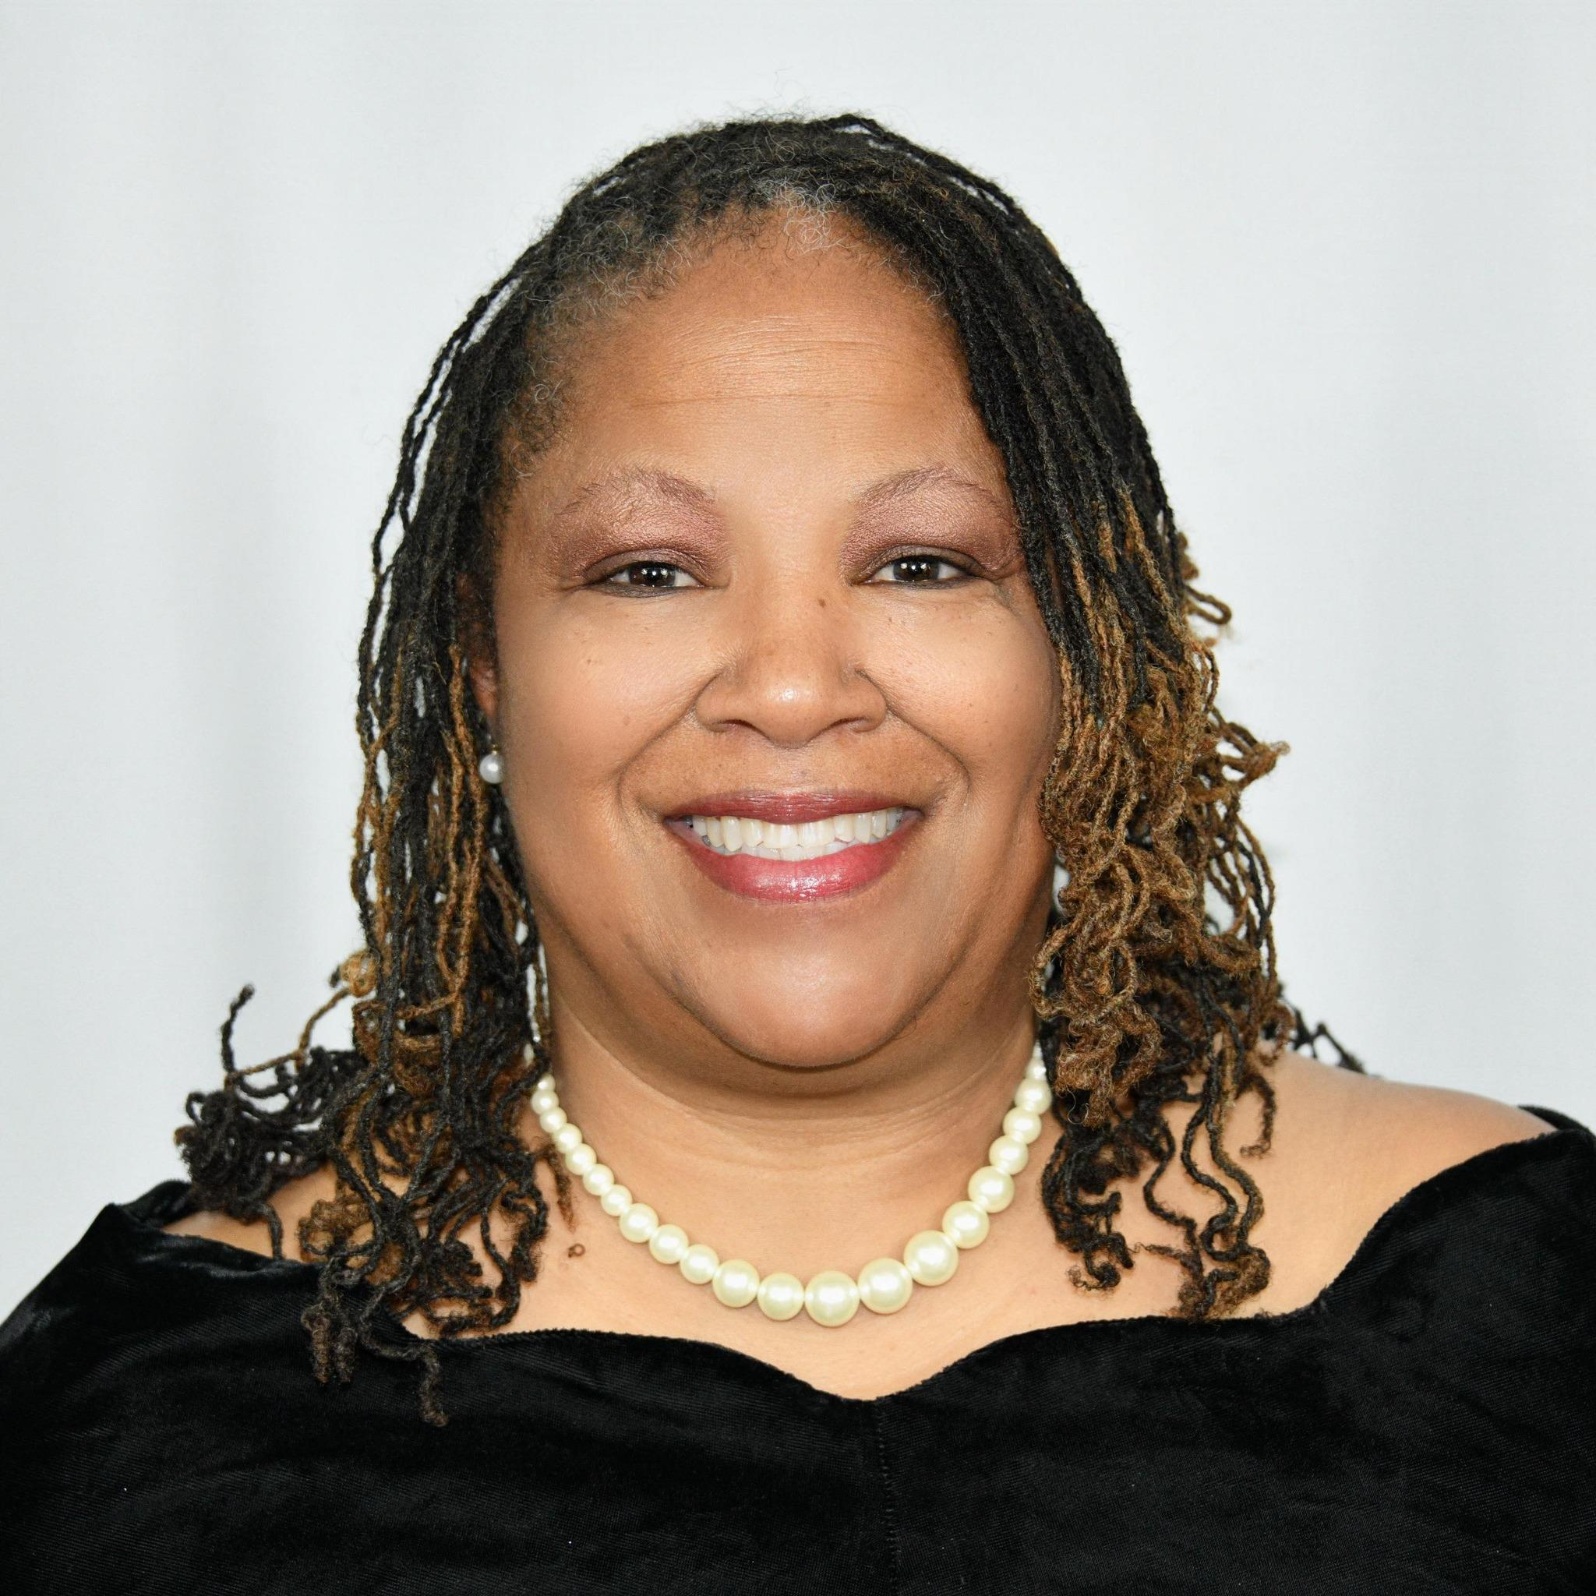
My name is Dr. Rich. I offer 29 years of experience as an educator. I have been a teacher, assistant principal, and principal. I have had the luxury of working at two other Early Colleges (one in Cumberland County and the other in Edgecombe County) prior to coming to Sandhoke Early College.
My educational philosophy is somewhat eclectic because it is a strong mixture of two educational philosophies, with evidence of other philosophical tenets that I have adopted. A majority of my educational philosophy tends to lend itself toward Progressivism, but I also have a firm foundation in Pragmatism.
I believe the purpose of education is to produce prepared students to become practical in their personal and professional lives by positively connecting to society as well as pursuing personal growth development as they mature. In doing so, students learn to think rationally so that they may become intelligent, contributing members of society.
I love teaching and learning; therefore, I believe strongly in my calling to help change tomorrow by helping the generation of today! Furthermore, I believe strongly in the African proverb, “It takes a whole village to educate a child”;
Goals:
1. As an educational leader, I intend to facilitate the development, implementation, and communication of a shared vision of learning that reflects excellence and equity for all students.
2. As an educational leader, I will promote the development of organizational, instructional, and assessment strategies to enhance teaching and learning.
3. As an educational leader, I will work with others to ensure a working climate that is safe, secure, and respectful of diversity for an atmosphere that is conducive to learning.
4. As an educational leader, I will demonstrate integrity and behave in an ethical manner.
5. As an educational leader, I will use excellent management and leadership skills to achieve effective and efficient organizational operations.
Finally, I believe that the three most important things to remember in education for me would be:
1. Teaching and learning occurs, regardless of one’s awareness of it
2. Teaching requires just as much heart as it does knowledge (students don&#39;t care what you know until they know that you care)
3. All children can learn, if given the right circumstances and the right material at the appropriate levels.
Looking forward to a great year!

